Three Victorian Community Sector CEOs to attend Harvard Business School
The Harvard Club of Victoria Celebrates the 2017 Non-Profit Fellowships
The Harvard Club of Victoria is delighted to announce the 2017 recipients of its Non-Profit Fellowship to study at the Harvard Graduate School of Business:
- Gerard Brody, CEO of the Consumer Law Action Centre;
- Teresa Jayet, CEO of Mallee Family Care; and
- Robyn Miller, CEO of MacKillop Family Services.
Gerard, Teresa and Robyn will be attending Harvard Business School’s Strategic Perspectives in Non-Profit Management course in Boston this July and undertaking a study tour of North American community sector organisations. The SPNM course is part of HBS’ Social Enterprise Initiative which applies innovative business practice and managerial disciplines to drive sustained, high-impact social change. Donations from Harvard alumni and proceeds from club events have made it possible for the Harvard Club of Victoria to send 36 Non-Profit Fellows to Harvard since 2001.
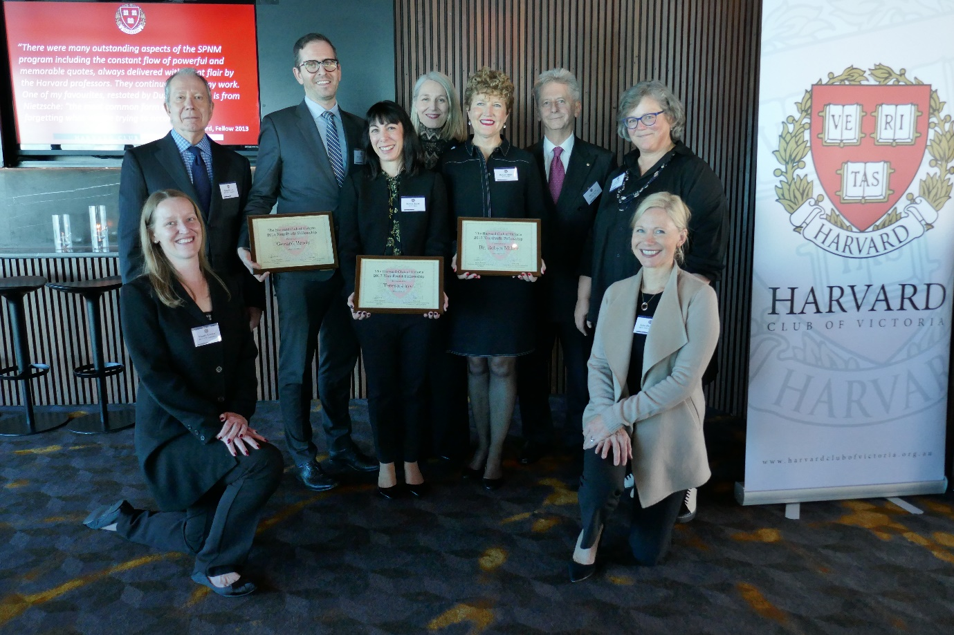
From left to right: Mandy Croker, NPF Committee; Kingsley Gee, NPF Committee; Gerard Brody, CEO, Consumer Law Action Centre; Teresa Jayet, CEO, Mallee Family Care; Jenny Proimos, President, Harvard Club; Robyn Miller, CEO, MacKillop Family Services; Bill Cowan, Founding Chair, NPF Committee; Alice Hill, Chair, NPF Committee; and Lisa Hennessy, NPF Committee.

Graduates of the Strategic Perspectives course are given a mission as they leave HBS:
“Lead. Be smart. Do good.”
The Harvard Club of Victoria is proud to support 36 smart leaders who are doing so much good in our community.
For more information on the HCV Non-Profit Fellowship, including a list of fellows, please visit the Harvard Club of Victoria’s website. Applications for the 2018 Fellowships will open in mid-December 2017.
To make a tax deductible donation in support of the Non-Profit Fellowship, please visit the Harvard Club of Victoria Non-Profit Fellowship page at the Good2Give.

Harvard Club of Victoria Non-Profit Fellowship Committee
Mandy Croker
Kingsley Gee MPH‘76
Lisa Hennessy MBA‘97
Alice Hill AB’81, PhDBE ’91 (Chair)

For enquiries about this press release or donations, please contact Alice Hill at nfpchair@harvardclubofvictoria.org.au

2017 Harvard Club of Victoria Non-Profit Fellows
Gerard Brody – Consumer Action Law Centre
Gerard Brody is CEO of the Consumer Action Law Centre, an independent, not-for-profit consumer organisation based in Melbourne. Consumer Action provides financial counselling, legal advice and representation to support vulnerable and disadvantaged Victorian consumers, and draws on its direct knowledge of the consumer experience in modern markets to pursue consumer interest campaigns and policy reform at both state and national levels.
Gerard is also the Chair of Consumers’ Federation of Australia, the peak body for consumer organisations in Australia, representing a diverse range of consumer groups, including most national consumer organisations. Gerard represents consumer interests on a range of bodies, including the Australian Securities & Investments Commission External Advisory Panel and the Australian Competition & Consumer Commission’s Consumer Consultative Committee.
The opportunity to complete the SPPM at Harvard will help me further develop my leadership capability and ability to steer Consumer Action to be a high performing organisation. As an advocacy organisation, I am hoping to develop my understanding of how we can measure the impact of work and support our people to effectively represent and advance the interests of groups that often miss out in the modern market economy.

Teresa Jayet –Mallee Family Care
Teresa has worked in the Human Services, Not-for-Profit Sector for more than 20 years in the Mallee region of Victoria. Teresa is the CEO of Mallee Family Care, the largest not-for-profit organisation which provides service delivery to North-West Victoria and South West New South Wales. Teresa’s experience in the community based sector has been in the areas of; community legal service, financial counselling, family law, disability services, mental health, family services, refugee programs and education, training and research.

Mallee Family Care has advocated strongly for more than 30 years for the most vulnerable and disadvantaged members of its communities. It has lobbied both State and Federal Governments to improve the lives of individuals and families, and has played a key role in advocating for the rights of children in Out of Home Care. The Agency is a key partner in many local community projects, and most recently a project called “Hands up Mallee”; this utilises a social impact framework to drive community change and improve community outcomes in the areas of family violence, education engagement and unemployment.

State and Federal Government reforms have impacted upon Mallee Family Care significantly in recent years. In order for the Agency to continue being a viable and thriving organisation it recognises that it will need to conduct its business differently for the future. The Strategic Perspectives in Nonprofit Management at Harvard Business School will provide an opportunity for Teresa to capitalise on the experience and expertise of others in their field, this exposure to the learnings of others will be invaluable. Teresa is keen to adopt new models to transform the Agency and improve outcomes for vulnerable members of her community.

Teresa is looking forward to sharing her experiences and new knowledge with the Board of Management and her Management Team, and is very appreciative of the opportunity that this Scholarship will afford her and is keen to provide ongoing support to the program.

Dr Robyn Miller – Mackillop Family Services
Dr Robyn Miller, PhD, is a social worker and family therapist with over thirty years’ experience in the community sector, local government and child protection. She was a senior clinician and teacher for fourteen years at the Bouverie Family Therapy Centre, La Trobe University, and part of an innovative team working with families who have experienced trauma and sexual abuse. Robyn has practised in the public and private sectors as a therapist, clinical supervisor, consultant and lecturer and was a member of the Victorian Child Death Review Committee for ten years. She was the recipient of the inaugural Robin Clark memorial PhD scholarship in 2004 and the state-wide award for Inspirational Leadership in Victoria in 2010. From 2006-15 she provided professional leadership as the Chief Practitioner within the Department of Human Services in Victoria, and has also worked as a consultant with the Royal Commission into Institutional Responses to Child Sexual Abuse.
Robyn is currently the CEO of MacKillop Family Services, one of the largest providers of specialist services to vulnerable and disadvantaged children, young people and their families in Victoria, New South Wales and Western Australia.

